Jonathan Tagney

10 December 2023

I think going into the individual game assignment I had the wrong mindset. Originally, I just intended to treat this like any other project. Finish what was required, get the grade, go on through the class as normal. But somewhere along the line, closer to when the project was actually getting finished and I noticed I was lacking quite a lot in comparison to what I should’ve been at I started actually having fun. Rather than treating it like a chore or a project that I needed to get a grade for, I started seeing it as more of an enjoyable assignment. Something that I didn’t feel bored at doing research on. From there, my outlook became a bit different. Even when I ran into issues, I’d get a different kind of joy when I actually ended up getting past it. Some of the memorable challenges were properly incorporating the timer as a sort of scoring system into the game. As well as the scoring system, I also struggled with getting some of the physics changes to work while I was changing things around, and I also had problems with incorporating the graphics into the game.

For the physics changes, I struggled with the ground checks working with the double jump and getting the proper teleporting scripts to work. I followed a mix of a few different tutorials on the double jump and mixed them together, leading to a working but initially not very good product. I got a bit of help with it, and eventually fixed the double jump and got it completely working. The ground check also started working properly as well so I didn’t have anymore issues with that. The teleporters were a bit tricky but I took the same method I did with the double jump and mixed together tutorials. After cross checking a few of them I got a working teleporter script that allowed me to properly teleport whenever the player is near one of them and presses the E key. I made little gates for the graphics to hopefully show that they are where you teleport. As well as those difficulties, the different changes I made to the physics would occasionally stop working because of moving the scripts around and switching the project between multiple computers. The switching between the computers would often make things corrupt or break and I would need to redo certain aspects of the coding and reattach the different scripts. The corruption and movement of files was the main issue I encountered throughout the entire project because it was the one constant I had to do that caused problems.

Fixing those was simple, but on the graphics portion I struggled for a long while. I couldn’t get the graphics to properly import because of the settings I was using. Unfortunately, there were very little resources online to actually say what was wrong in my situation. The graphics were importing well but the colors were becoming jumbled. After some searching and a bit of help from my peers, I was able to fix the settings so that the graphics weren’t being compressed and would retain their details. Completing this allowed me to actually get my graphics in the game and looking like how they did in the program I did the art in. My animations also started looking normal and worked correctly with the size of my character using minimal effort.

Despite the issues I encountered and losing many hours over possibly even small fixes. I genuinely started to enjoy the process of making the game and seeing the progress. The process of creation and seeing a project coming along started to change my mind a bit about the situation. I started to enjoy the entire project, and learning more about programming. I also can now look back and see that a lot of the different things I got stuck up on were simple fixes that I can do now in hardly any time in comparison to the hours it took to get through it the first time. Through all of tutorials, I started to properly understand what was actually going on and relatively grasp what the code was doing.

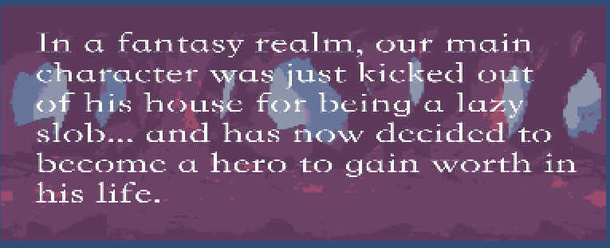

Basic premise of the original idea for the game.

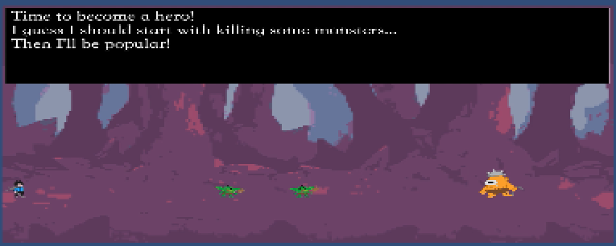

Original design of enemies/main character and environment taken from the animation.

